***Name :-*** Shubhi Gupta

Emailid:- gshubhi2604@gmail.com

***Internship Day2-Task-2***:-

***Creating a repo***:-

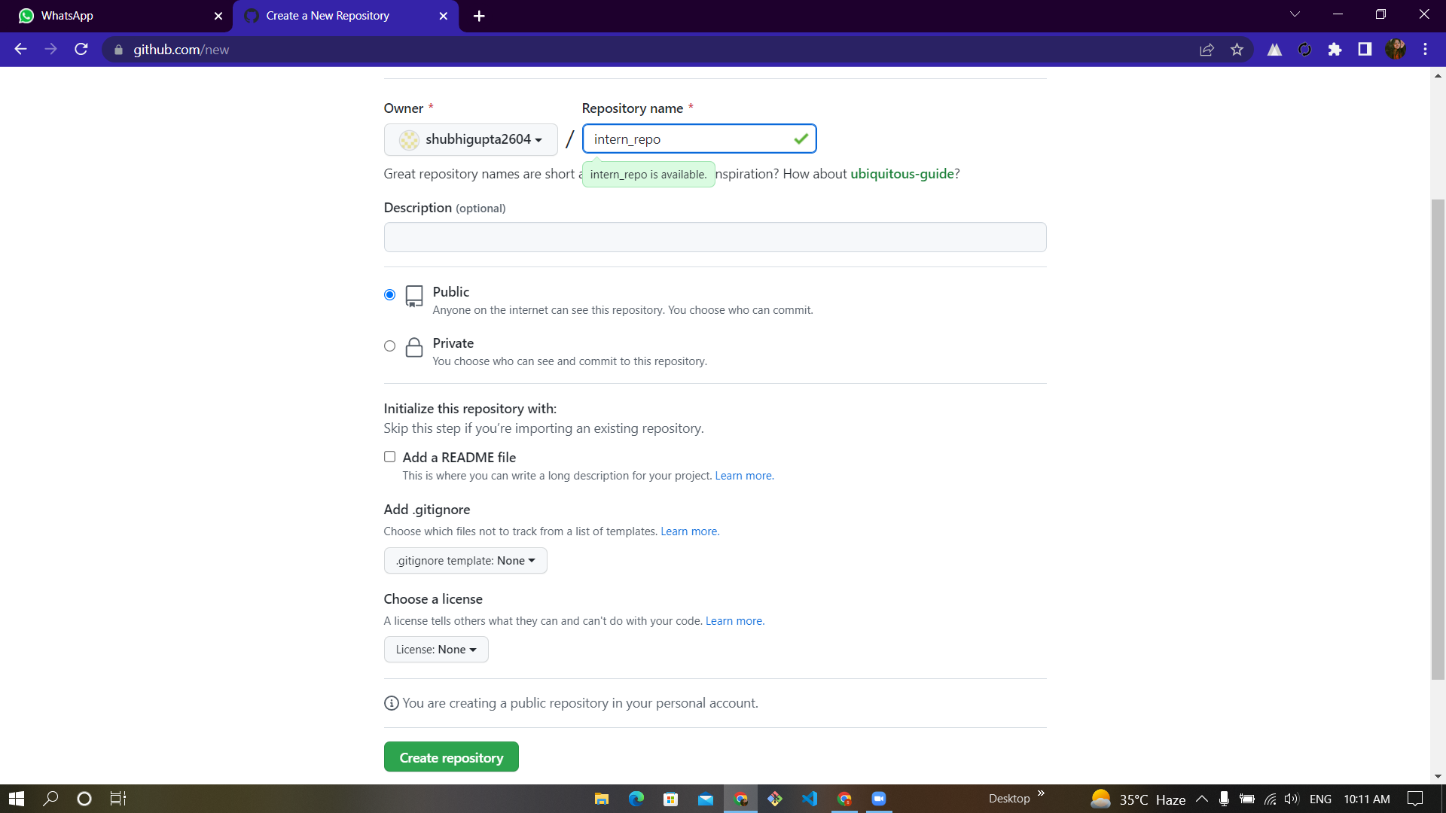

***Cloning a repo***:-

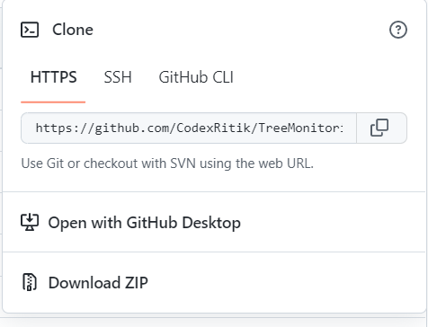

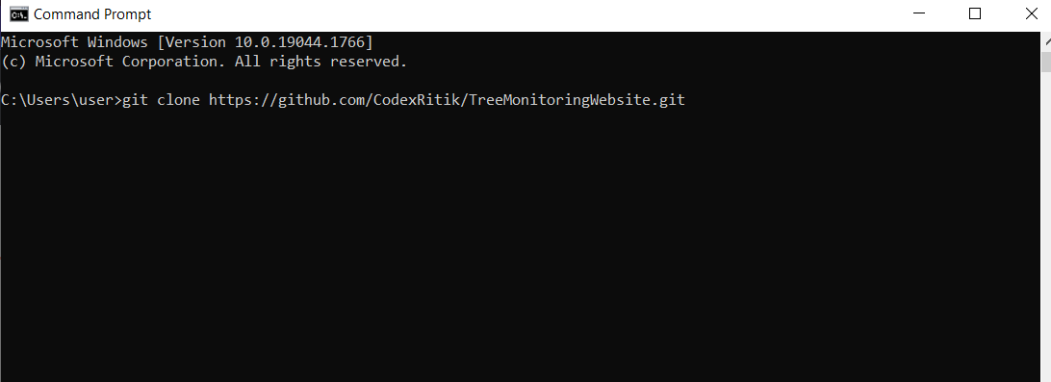

***Commit in a repo***:-

